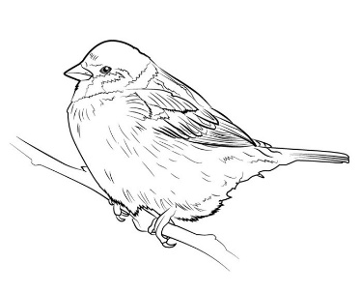
Songbird Medical
501 Plains Road East, 2nd Floor Ph: 905-635-7313
Burlington, ON L7T 2E2 Fax: 905-635-2464

March 27, 2024
To the Patients of Dr. Shelia Middlebrook

This is to inform you that effective immediately, Dr. Middlebrook will be on Medical Leave from her practice with an unknown end date.

We are currently in the process of hiring a locum doctor to cover for her and will update everyone once we know more.
Robin, our Nurse Practitioner, is still working and available to see patients.
All acute and urgent issues can still be seen in our after hours clinic by calling 905-635-7313 Monday - Friday from 5pm - 8 pm and Saturday From 9 am - 12 PM.

We can appreciate how frustrating this process can be and apologize for any inconvenience this may cause. Your patience and respect for our staff are critical during this time and we are working diligently to find coverage.
Sincerely

Julie McCarthy
Songbird Medical
Clinic Manager

