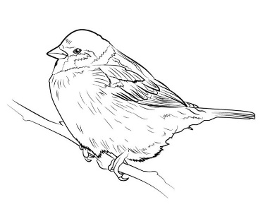
Songbird Medical
501 Plains Road East, 2nd Floor Ph: 905-635-7313
Burlington, ON L7T 2E2 Fax: 905-635-2464

Dear Patients,

I thank you all sincerely for your patience over the past month, and for all the kind words of support regarding my move back to my home province.

I have good news to share with you - the lovely Dr. Britt Harrison will be taking over my practice! At this point in time, there is nothing you need to do to become her patient, as she is assuming the entire practice. Dr Harrison is originally from Burlington and completed her Family Medicine residency training at McMaster in 2019. Like myself, she is moving back to her hometown to be closer to family.

I am so fortunate to find a physician who I am confident will be a good match for my practice. As many of you know, family medicine is in a crisis state in Canada right now. There are currently over 2 million residents in Ontario with no family physician. This number has been projected to climb to 1 in 4 Ontario residents by the year 2026. I am grateful that none of you will be part of this statistic.

There will be a short transition as Dr Harrison starts on August 1, 2024, and as you will recall from my last letter, I will be leaving Songbird Medical as of March 31, 2024. Your interim care will be shared by two wonderful physicians, who are both well known to Songbird Medical, having provided practice coverage with us before. Also, backup care will be provided by Dr Shelia Middlebrook (whom many of you have met over the years) and her fantastic Nurse Practitioner, Robin.

You will therefore be able to continue just as usual, booking appointments, and using the After-Hours Clinic.

As a reminder, the After-Hours Clinic runs Monday to Friday evenings from 5-8 PM, and Saturday mornings from 9 AM to noon. This information, as well as other up-to-date information and news on the clinic, is always maintained on our website, www.songbirdmedical.ca.

Sincerely

Dr. Courtney MacEwan

