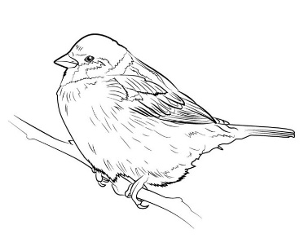
Songbird Medical
501 Plains Road East, 2nd Floor Ph: 905-635-7313
Burlington, ON L7T 2E2 Fax: 905-635-2464

January 2024

My dearest Patients ,

I am writing this letter to share with you all, a bittersweet announcement:

After March 31, 2024 I will no longer be your family physician as I will be moving back to my home province of Nova Scotia.

When I set up my practice eight years ago, and as we transitioned to Songbird Medical four years ago, I had planned to be providing primary care for you for the remainder of my working career.

However, evolving family circumstances have led to the decision by myself and my husband that we must move back to my home province. As a family physician, I would be greatly remiss if I did not care for my own family.

I can assure you all, this has not been a light or easy decision, and I will endeavour to make the transition as smoothly as possible. I am working towards finding a family physician for my practice, and will update you all soon.

I want to extend heartfelt thanks to my many wonderful patients, and to the community of Burlington, for what you have given me and my family over the past ten years. I am truly grateful.

Please note that for the last two weeks of March, I will only be able to provide same day urgent care, as there will be a significant amount of administrative work I will need to complete prior to my departure. Please do book accordingly, as I will not be able to accommodate extra hours in my schedule at that time, as time will be tight.

I wish each and every one of you all of the best in the future, and I will truly miss you. I hope you have enjoyed being a part of my journey as much as I have enjoyed being a part of yours.

Yours truly,
Dr. Courtney MacEwan

